1. Let’s talk about different options along with command 🡺 mongod  
   List all the options available for mongod command by giving the command mongod –help
2. 
3. 
   1. 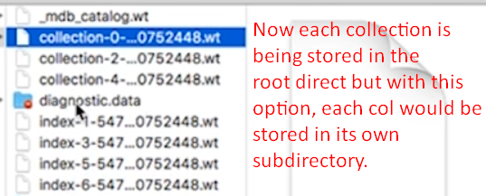
4. 
5. Really good with high performance storage engine and default one.